CS 148

Natasha Geffen

Assignment: Final Project

Cat Courses

Version <1.0>

Table Of Contents

Time Log 3

Introduction 4

Purpose 4

Definitions, acronyms, and abbreviations 4

Overall Description 4

Story Board 5

Data Dictionary 6

ER- Diagram 7

Schema 8

Specific requirements 9

|  |  |  |  |
| --- | --- | --- | --- |
| Time Log | | | |
| Estimated time to complete assignment => | | | 70Hours |
| Date | Time Spent  (in hours) | Description | Author |
| 11/3/18 | 1 | Read through project requirement and brainstormed site ideas | Natasha Geffen |
| 11/4/18 | 2 | Researched online databases |  |
| 11/4/18 | 4 | Set up databases |  |
| 11/10/18 | 1 | Made final decision and laid out idea |  |
| 11/11/18 | 1 | Made main pages for site |  |
| 11/16/18 | 1 | Worked on pulling data from the registrar |  |
| 11/16/18 | 1 | Worked on base pages |  |
| 11/28/18 | 2 | Worked on form |  |
| 11/30/18 | 2 | Worked on form and git problems |  |
| 12/1/18 | 6 | Form and story board |  |
| 12/2/18 | 5 | Worked on all pages of site |  |
| 12/4/18 | 5 | Worked on adding/updating form |  |
| 12/5/18 | 5 | CSS |  |
| 12/6/18 | 10 | Finishing touches, CSS, getting everything to work |  |
|  |  |  |  |
|  |  |  |  |
|  |  |  |  |
|  |  |  |  |
|  |  |  |  |
|  |  |  |  |
|  |  |  |  |
|  | 46 hours | <=Total Time Spent |  |
|  |  |  |  |

# Introduction

### Purpose

The purpose of this document is to describe the requirement specification for the web site “Cat Courses”.

The intended audience for this document is UVM students

*First it is the contract between you and the client. Second it is for the developer of the site. Two primary goals are:*

1. *Client gets a very good understanding of what you will be delivering.*
2. *Developer has a very good understanding of what they are going to create.*

### Definitions, acronyms, and abbreviations

*Sample for the client:*

ER Diagram – a diagram to represent the data you want to save with your system

W3 Validation – refers to both Html and CSS validation tool provided by the W3c.org. the html validator is located at:

<http://validator.w3.org/>

with the CSS validator located at:

<http://jigsaw.w3.org/css-validator/>

# Overall Description

As a student, picking courses can be stressful. This site was created to make life easier for students. With the click of a button, they can search what other students have said about UVM courses and instructors. This site also makes it easy to review courses for future students to see.

# Story Board

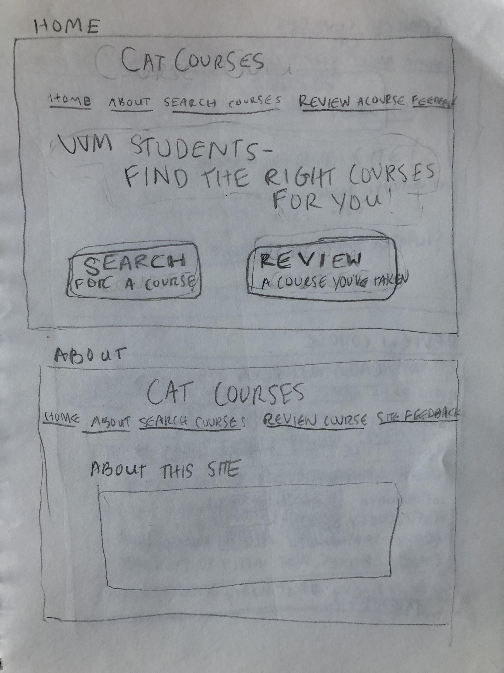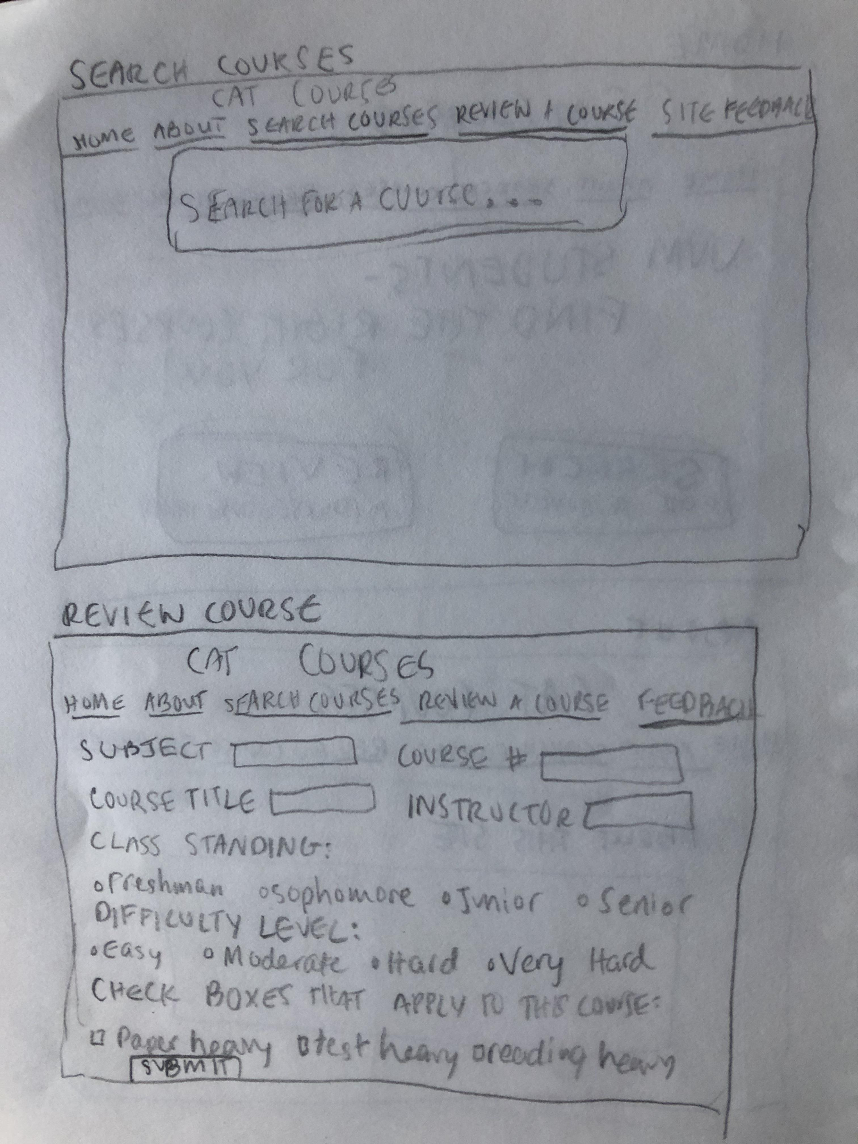

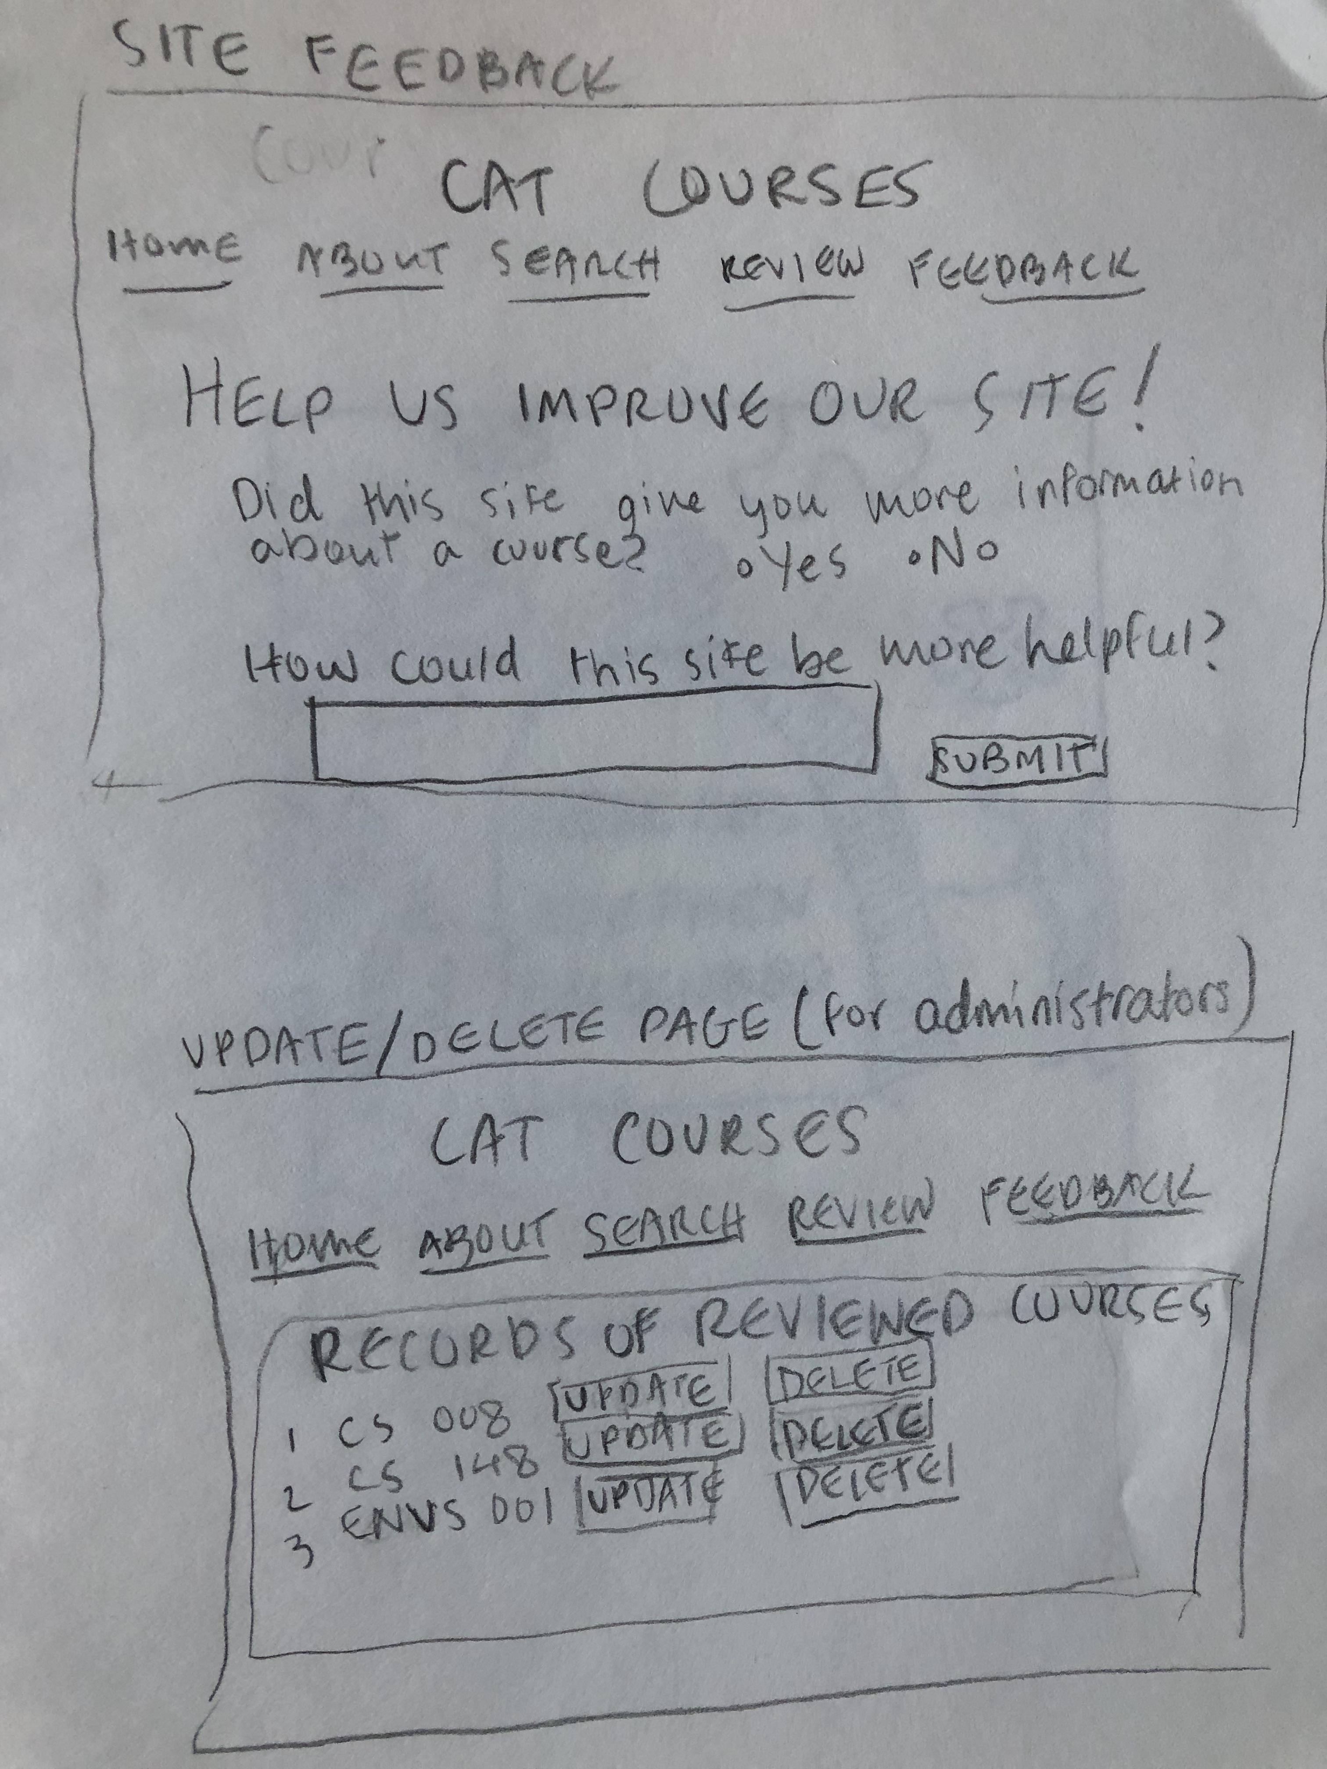

# Data Dictionary

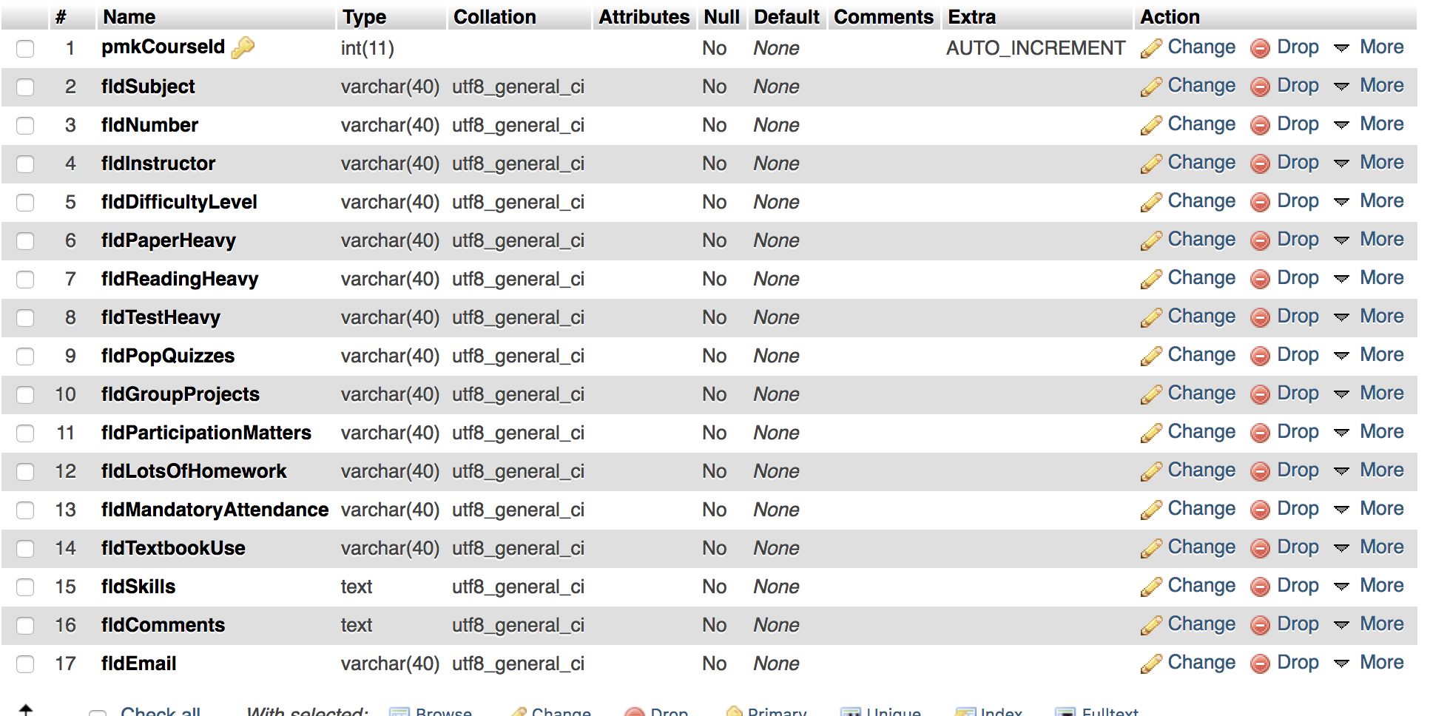

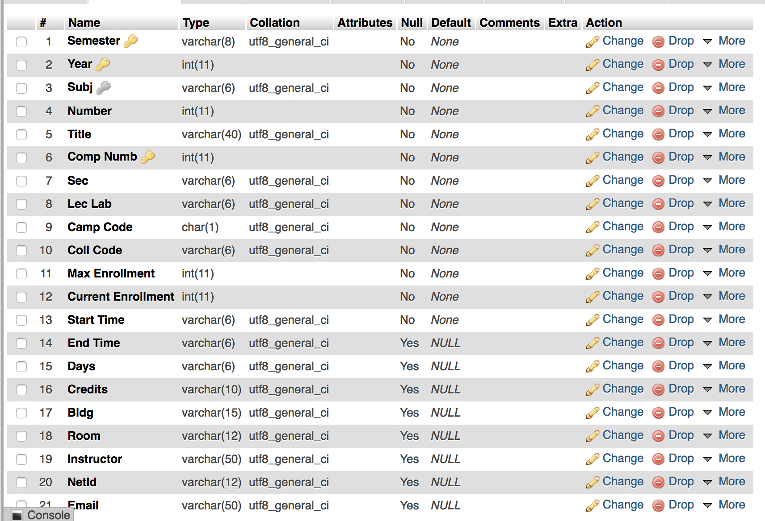

# ER- Diagram

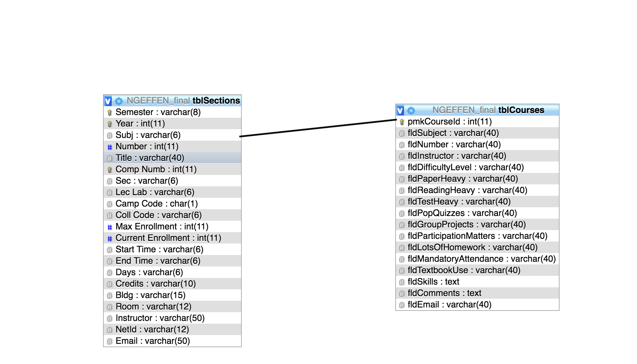

# Schema

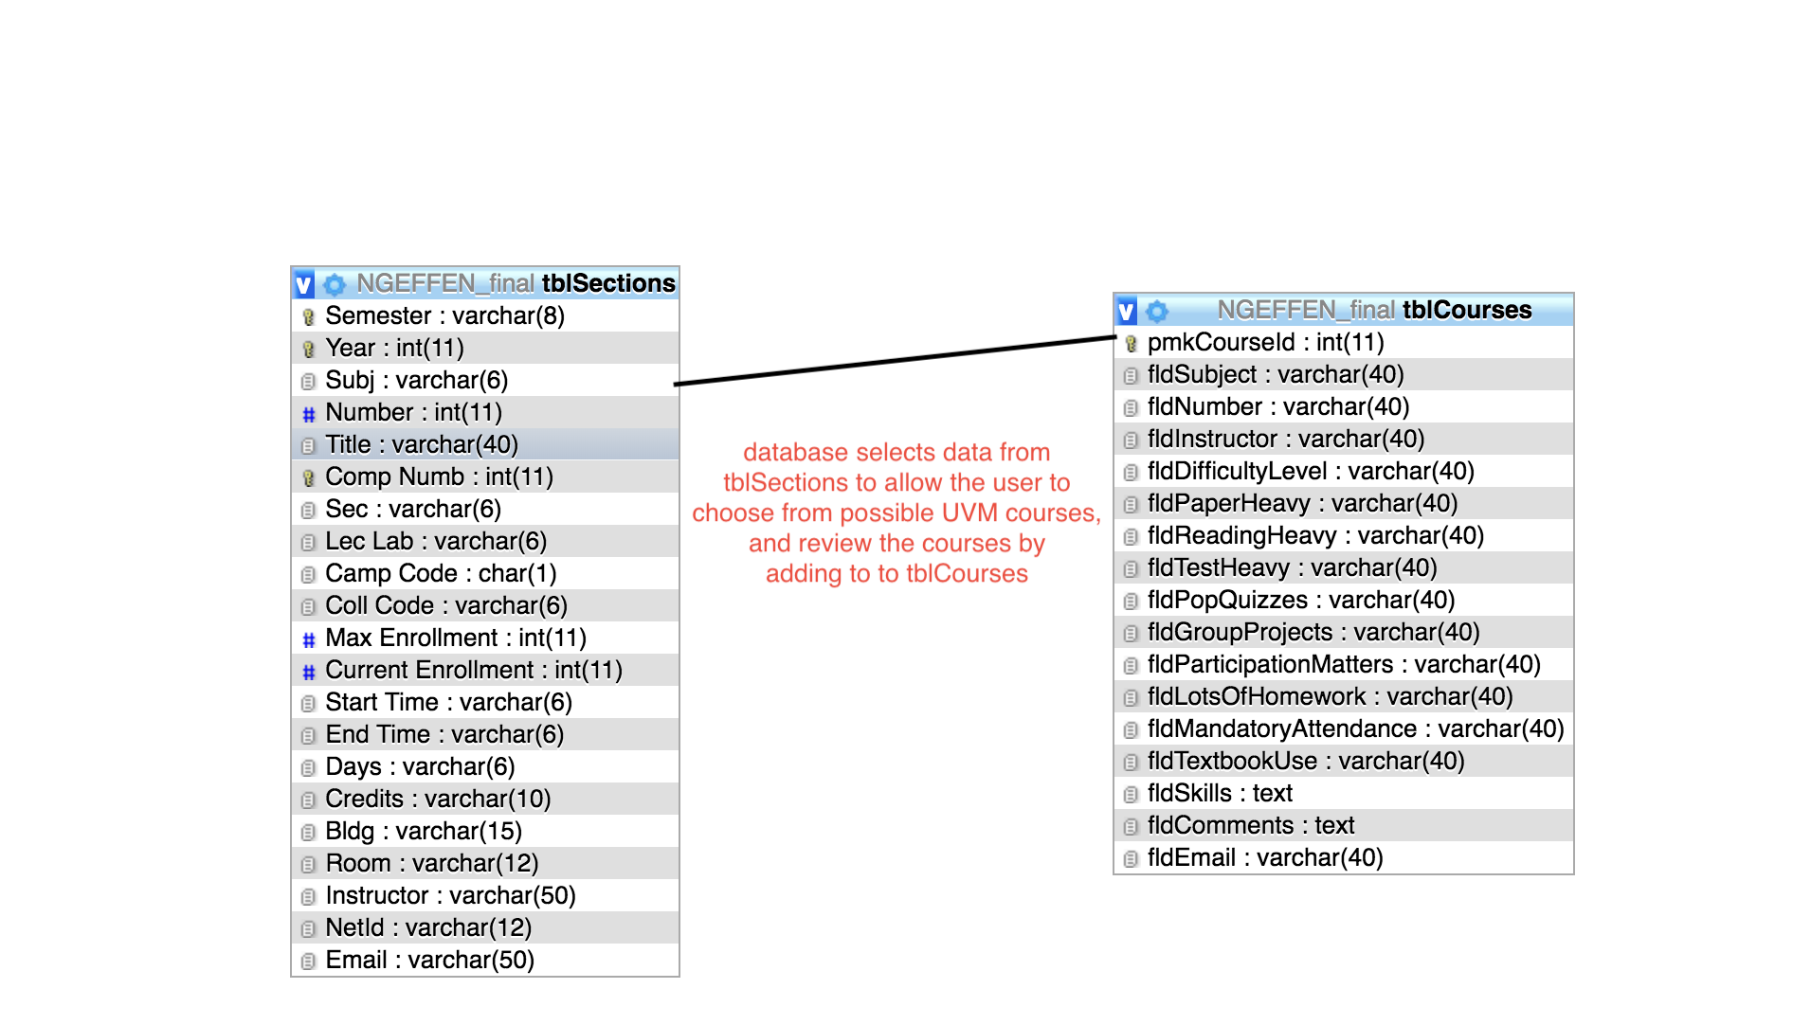

# Specific requirements

1. *Title: Cat Courses*
2. Main Page: introduces user to concept of site
3. About page: answers potential questions about site that the user might have
4. Review course: allows user to fill out a form to submit review
5. Search courses: allows user to search for course they want to read about
6. Browse recent: allows user to browse recent course reviews
7. Feedback page: user gives feedback about site and whether they found it helpful or not